- The pledges announced in the Conservative and Labour parties' manifestos will have little economic impact according to our modelling, especially considering the impending fiscal consolidation that both studiously ignore.
- Consolidation is needed – the UK’s public finances are in a very weak position. We expect UK nominal GDP growth to be lower than the effective interest rate the government will pay on debt over the next five years. Of the advanced economies, only Italy has similarly poor debt dynamics.
- However, the refusal by both Labour and the Conservatives to rethink the UK's flawed fiscal rules will hinder growth prospects and force more policy tightening than is absolutely necessary.
- The manifestos of both parties imply the plans to tighten fiscal policy by 3% of GDP inherited from the current government will be implemented. New tax and spending pledges are small in scale and fiscally neutral. Indeed, scenarios run on our Global Economic Model find their manifesto pledges will have a negligible impact on GDP growth and asset prices.
- We doubt either party would stick to its manifesto plans, particularly Labour if it wins a large majority. A more likely scenario is that Labour would tweak the debt rule to remove the distortionary effects of losses on the Bank of England's Asset Purchase Facility. This would allow higher spending and could result in slightly stronger GDP growth.
UK fiscal policy has become highly dysfunctional, with the current setup imposing scant debt discipline and offering little support to economic growth. The general election on July 4 provides the opportunity for a reset. But the manifestos published recently by the Conservative and Labour parties offer little reason to expect much improvement on either front over the next five years.
We forecast average nominal GDP growth will be lower than the effective interest rate the UK government will pay on its debt over the next parliament. Of the advanced economies, only Italy is in a similarly poor position (Chart 1). What’s more, this projection is predicated on fiscal policy being tightened by 3% of GDP by 2028-2029, in line with the plans of the outgoing administration.
Chart 1: The UK's debt dynamics are among the most challenging of the advanced economies
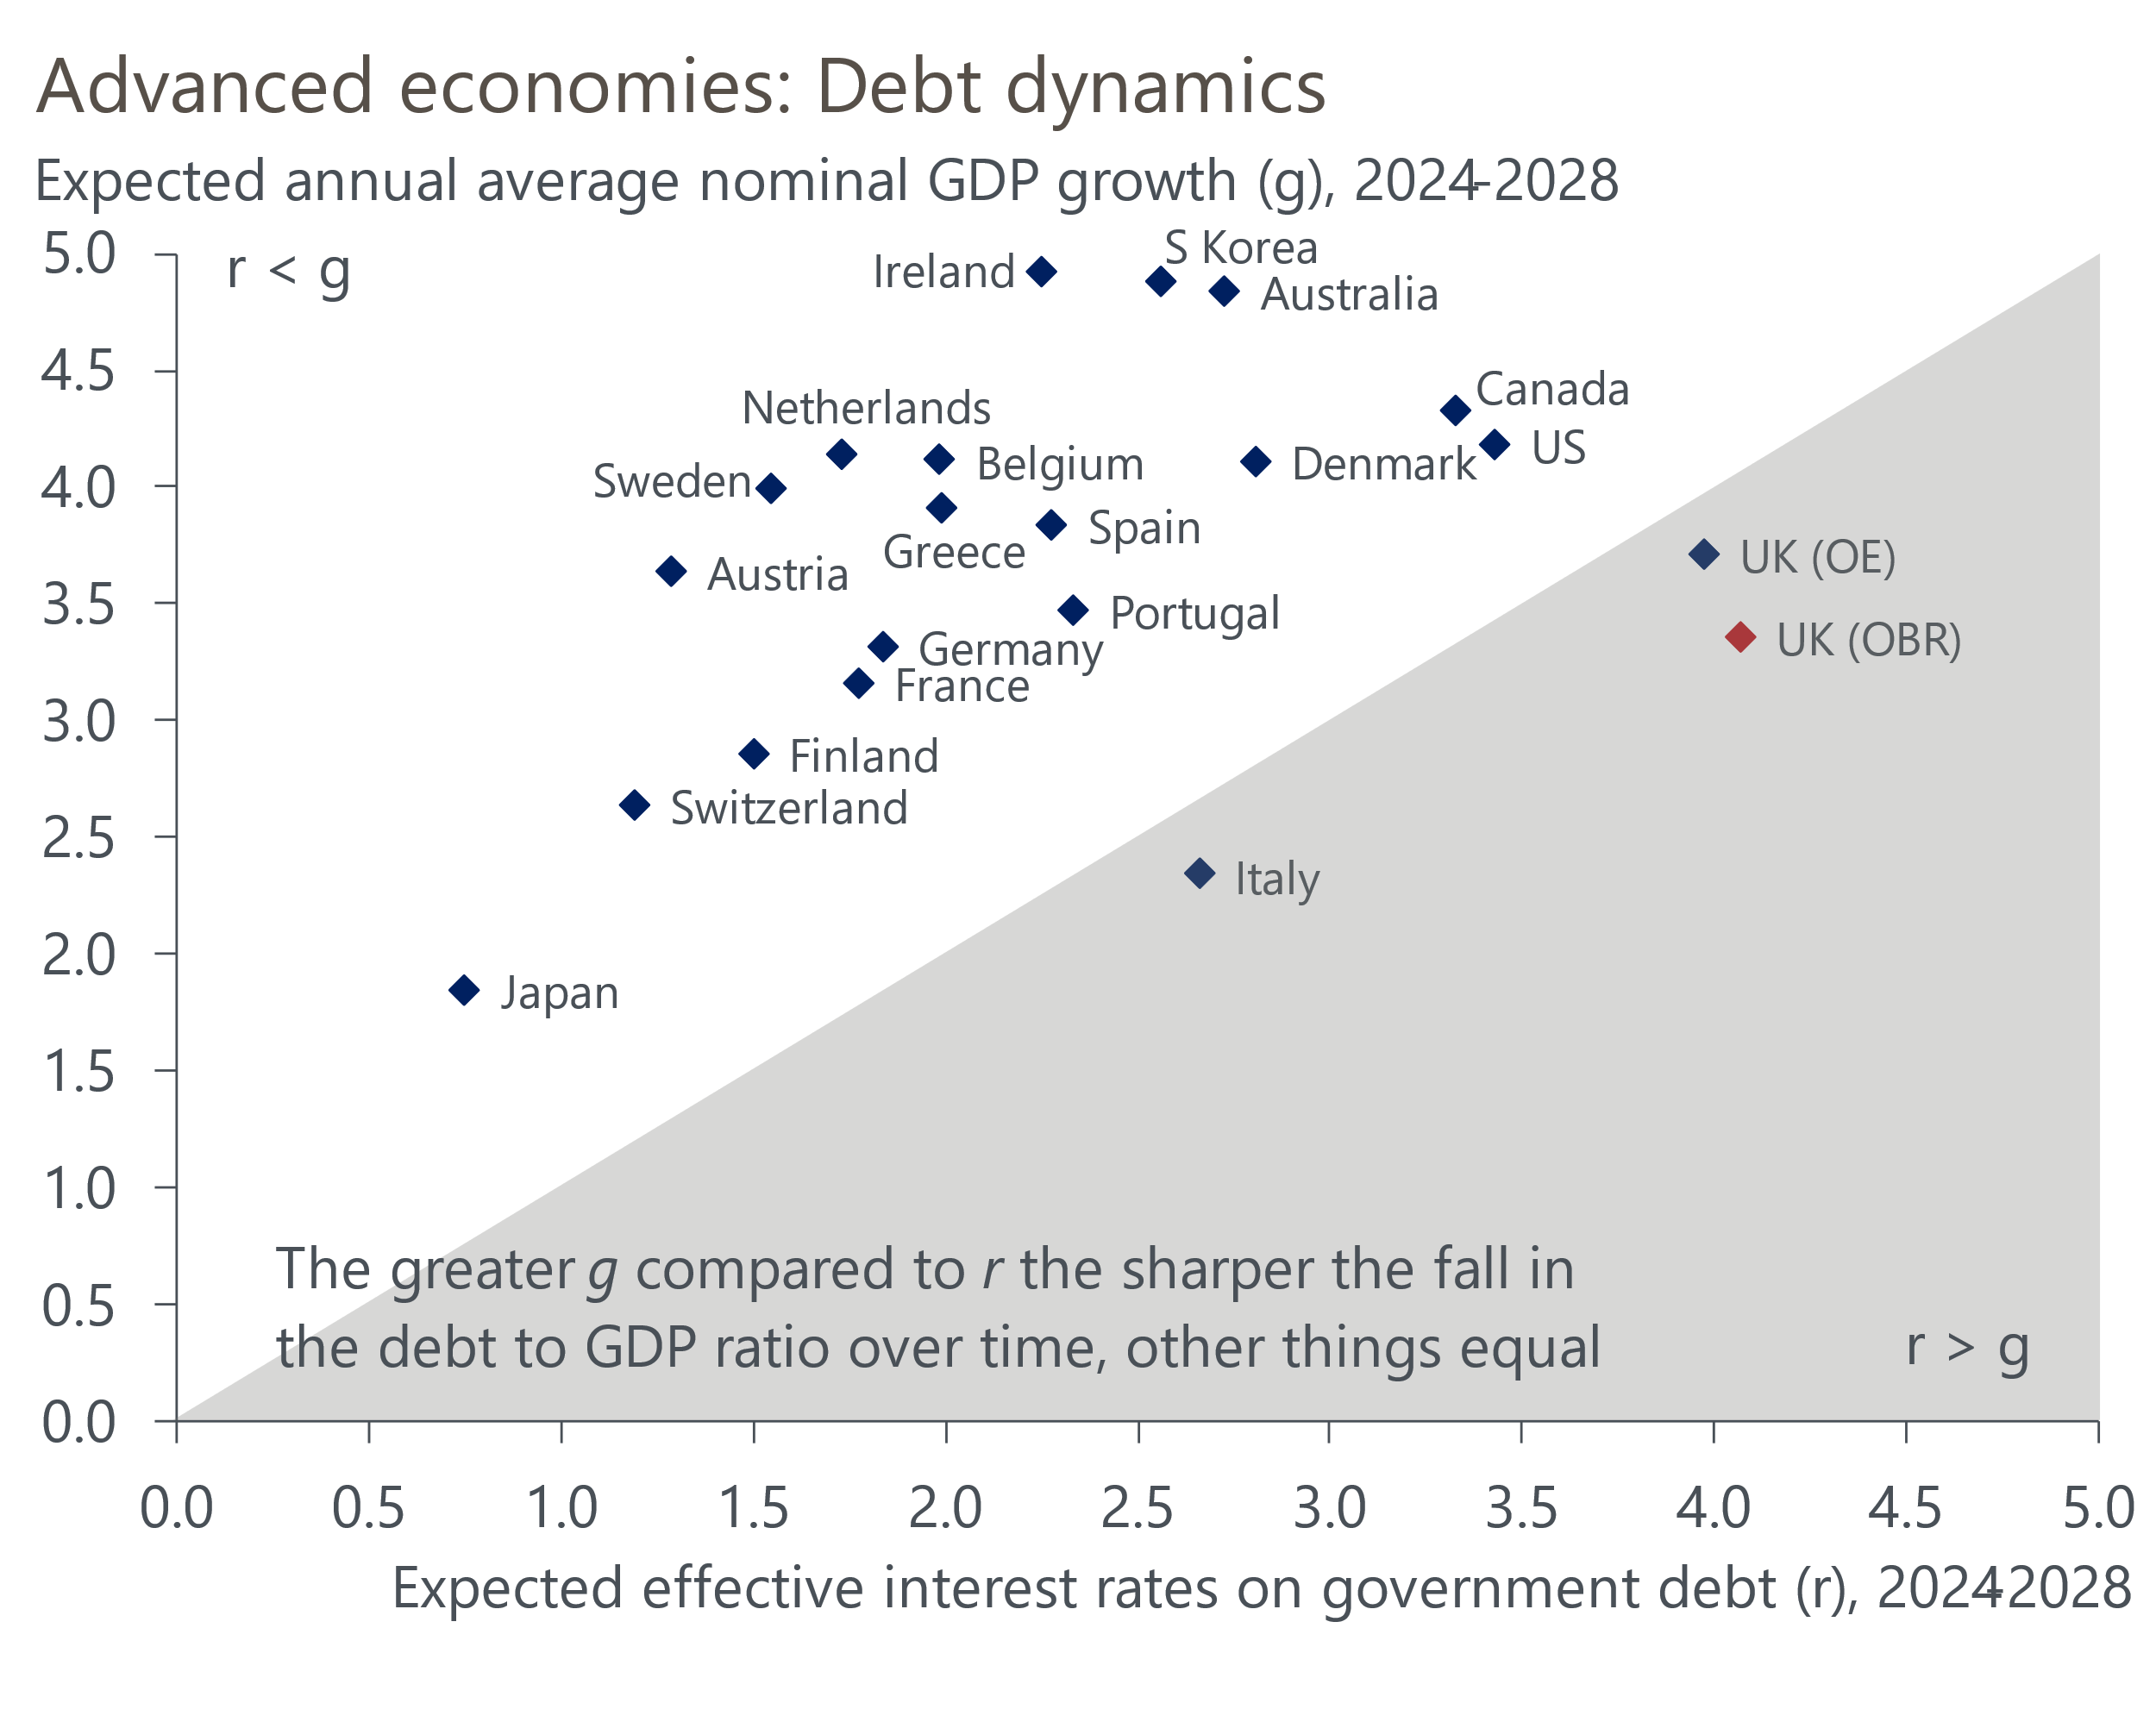
Source: Oxford Economics

Both parties have committed to keeping the flawed debt rule
The Office for Budget Responsibility's latest forecasts assume that even with the substantial tightening of fiscal policy planned by the current Conservative government, the public sector net debt-to-GDP ratio will rise over the next four fiscal years before a small fall in 2028-2029. But that forecast was based on financial market pricing in mid-January when markets were much more bullish about the pace of interest rate cuts. Updating these forecasts for current market pricing implies that the already slim £9bn headroom that the government had against the net debt rule would be halved.
Similarly, the OBR's current forecasts assume a rebound in productivity growth that's stronger than most other forecasters anticipate, including ourselves and the Bank of England. The OBR pared back its optimism a little in its March forecast, but there's a danger that it cuts its productivity assumption further in a future forecast. All else equal, such a revision would increase the OBR's borrowing forecast and therefore require the government to tighten policy more to comply with the fiscal rules.
Labour has vowed to change the borrowing rule, targeting a balanced current budget (i.e., day-to-day spending matched to government revenue), rather than setting a limit for the broader public sector net borrowing measure. Theoretically, this would allow scope to increase capital spending. However, Labour has also committed to keeping the current government's debt rule, which says that public sector net debt (excluding the Bank of England) must fall as a share of GDP in the fifth year of the OBR's forecast. Due to the impact of the Treasury's indemnity on BoE losses when it sells gilts held in its Asset Purchase Facility, the debt rule is likely to be the binding constraint on fiscal policy throughout the next parliament. So this effectively leaves both parties with the same limited leeway on fiscal policy.

Both manifestos offer a small scale, fiscally neutral, package of measures
The current government's fiscal plans on which the OBR's forecasts are based involve large tax increases via 'fiscal drag', with many tax thresholds being frozen rather than rising in line with inflation and severe spending restraint. Neither party's manifesto acknowledges this inheritance. The new tax and spending pledges are fiscally neutral and very small in scale, so both parties have implicitly committed to implementing the bulk of the policies planned by the outgoing administration.
The proposed tweaks to the existing plans shown in Chart 2 reflect where their priorities lie between minimising the increase in the tax burden (Conservatives) or easing the squeeze on the funding of public services (Labour).
Chart 2: The manifestos imply small tweaks to the existing fiscal plans
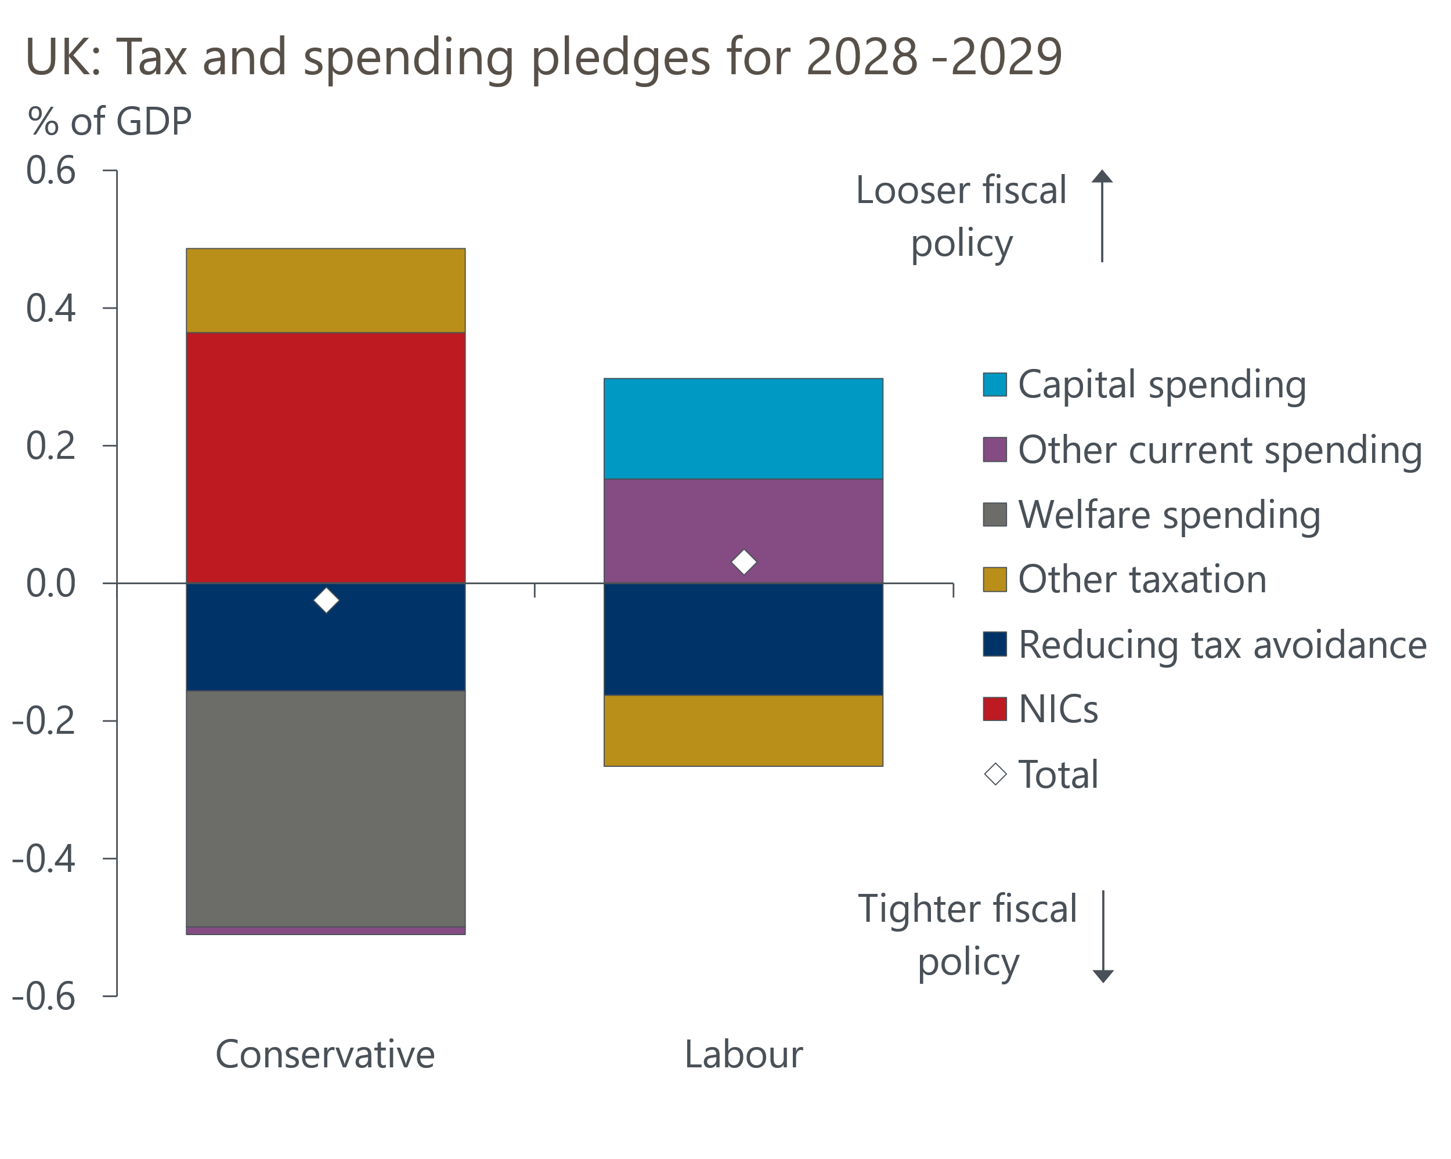
Sources: Oxford Economics calculations using Conservative & Labour party manifestos
In both cases, the parties assume around £5bn (0.2% of GDP) of extra tax revenue will be generated each year by anti-avoidance measures. This tactic is often used in manifestos and at fiscal events to make the sums add up, but there is scant supporting detail, and the pledges look very hard to justify. Similarly, the Conservatives plan to reduce spending on welfare by £12bn (0.3% of GDP) by 2029-2030 via a range of measures, many of which are aimed at reducing health-related benefits claims. That such a large sum could be saved from these measures looks highly questionable.
But the bigger picture is one in which past fiscal choices play a far greater role in the outlook than manifesto pledges. Regardless of which party wins on July 4, government revenues as a share of GDP will rise to a level that's not been seen on a consistent basis since the aftermath of World War 2 (Chart 3). Public sector net investment, already very low by international standards, will likely drop to its lowest level in 15 years. And public sector current spending will steadily fall as a share of GDP. Given the healthcare demands created by an older and more sickly population and the desire of both main parties to increase defence spending, to make the sums add up there would have to be large real terms spending cuts for unprotected departments such as the Department for Culture, Media and Sport, and the Ministry of Justice.
Chart 3: The manifesto plans do little to alter the shape of fiscal policy over the next five years
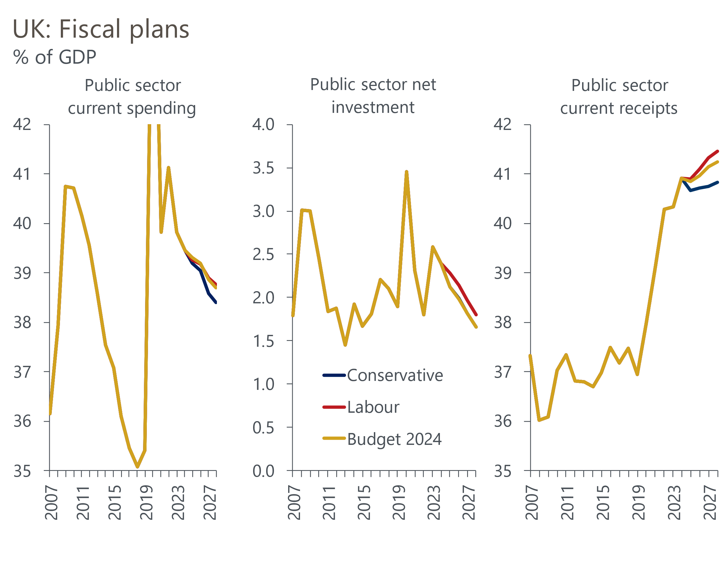
Source: Oxford Economics calculations using forecasts from OBR and Conservative & Labour party manifestos

The manifesto pledges will have a negligible impact on growth
To analyse the impact of the manifesto pledges we ran simulations on our Global Economic Model. Our starting point is the OBR's March 2024 forecast, adjusted to be consistent with current financial market pricing. We've then applied the new fiscal assumptions to the OBR forecast 'ex ante' and solved the model to encompass any second-round effects from the policies. For example, higher government spending could increase the wages of government employees or increase the volume of goods and services bought by the public sector, and this additional activity would impact the economy and the public finances via higher tax revenues.
Our approach enables us to analyse the broader macroeconomic impact of the two parties' policy decisions beyond that on public finances. It also allows us to capture the dynamic effects of the policies on the public finances – a more comprehensive approach than the static framework adopted by the parties themselves.
Though we have concerns about the credibility of the parties' claims about the fiscal savings they can make from clamping down on tax avoidance and reducing welfare spending, we've taken the pledges at face value for the purpose of this analysis.
Our modelling finds very little difference in GDP outcomes between the current government's plans and the manifestos of the two parties (Chart 4). This is unsurprising given that the manifestos were fiscally neutral and the individual policy measures were so small. There are similarly small impacts on inflation, unemployment, and asset prices, while monetary policy would be loosened at a similar pace across each scenario.
Chart 4: The difference in GDP outcomes is negligible
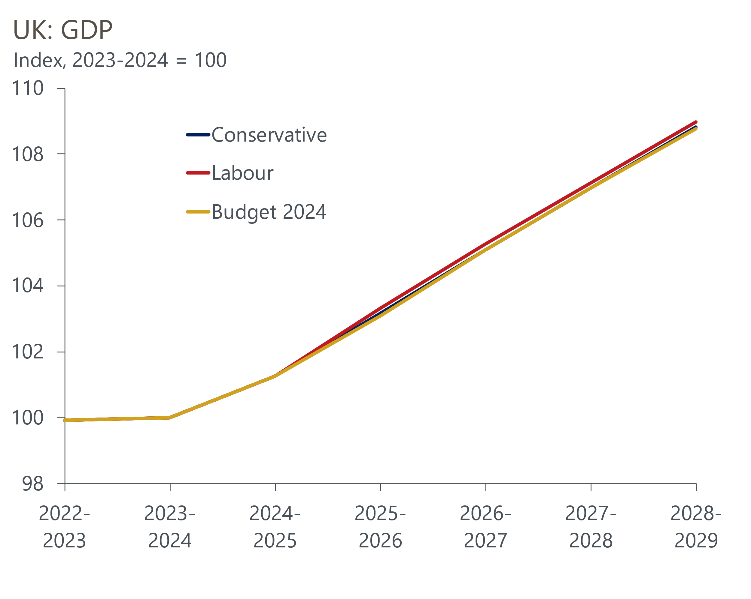
Source: Oxford Economics
There are some limitations to our work. Labour hopes that planning reform will boost potential output. This is a laudable aim – reform of the planning system was one of the seven recommendations we made in our proposals for boosting potential output we published before the March 2023 Budget. But at this stage, there's not enough detail available to be confident about what – if any – impact Labour's reform agenda will have on supply potential.
On the flip side, our scenarios don’t make any adjustments to baseline demographics assumptions. Both parties talk of the need to control immigration, and hint at a desire to cut net inward migration more quickly than the pace assumed in the OBR's forecast. But neither party has offered any suggestions on the level they would like to achieve, so we've been unable to include this aspect in our simulations. Had we included lower net inward migration then the scenarios would have likely shown poorer growth outcomes than the OBR's latest forecast, and both parties not complying with their main fiscal rule.

We expect a Labour government to follow a slightly different path to its manifesto
According to opinion polls, a Labour victory appears certain on July 4. The party also appears likely to win a large majority, probably much bigger than the 80-seat majority the Conservatives won in the previous election in 2019. This would give Labour plenty of leeway to shape policy as it sees fit. In this situation, we think it's likely that Labour will move away from some of its manifesto promises. In particular, when confronted with the realities of conducting a spending review, we think that a Labour government would increase the spending envelope to provide better funding for public services.
The obvious way to provide more room for higher spending is to tweak the net debt rule so that it excludes the impact of the cost of the Treasury indemnifying the BoE for losses when it sells gilts held in the APF. As we've argued before, including APF costs leaves fiscal policy open to the heavy influence of one-off effects, with a very uneven profile from year-to-year. The OBR's latest forecast assumes just over £20bn of losses on gilt sales in the final full fiscal year of the next parliament (2028-2029). We expect Labour to remove these highly distortionary effects from the net debt measure, using the extra fiscal space to ease the squeeze on government spending.
We've run an alternative scenario where Labour removes APF losses from the net debt rule and uses 75% of the extra headroom to boost departmental current spending, with the remaining 25% spent on extra government investment. This would result in slightly stronger GDP growth over the course of the next parliament, while still complying with the new, amended debt rule (Chart 5). Looser fiscal policy would also mean slightly tighter monetary policy, with the profile for Bank Rate being around 25bps higher than the current market curve in the second half of the parliament.
Chart 5: Excluding APF losses from the debt rule would allow more public spending and boost growth
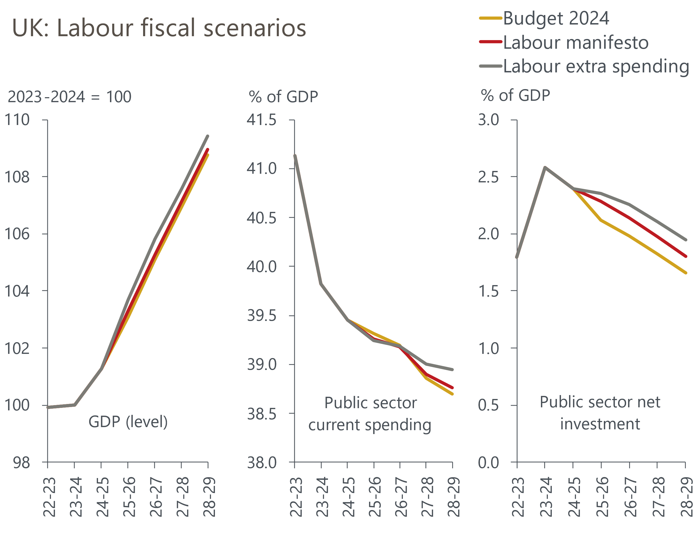
Source: Oxford Economics
We think this is a more plausible scenario than Labour following its manifesto to the letter. But even under this scenario, public sector current spending would fall as a share of GDP over the course of the parliament. Given Labour's desire to improve decaying public services, the party could look for further ways to boost funding.
One option would be to introduce tiering on bank reserves. Though Chancellor-elect Rachel Reeves recently said Labour has no plans to do so, its disavowal was much less firm than the denials it has made in other areas, most notably about whether the party would raise any of the main taxes (Labour's manifesto ruled out increasing income tax, national insurance, and VAT). A Labour government could also raise other taxes, such as capital gains tax, or reform council tax in a way that raises additional revenue, perhaps by adding extra bands for higher-value properties.
Another open question is the timing of fiscal consolidation under a Labour government. The party inherits plans that imply a substantial tightening of policy this year (1.6% of GDP) followed by a more even pace averaging 0.4% of GDP per year in subsequent years.
Labour could decide that it would be politically advantageous to front-load tightening, bringing forward more of the spending cuts from later years into 2025-2026. This would offer both a better chance of pinning the blame on the outgoing Conservatives while also getting the bad news out of the way early and allowing longer to rebuild. This scenario implies a more aggressive approach to loosening monetary policy.
But equally, an autumn fiscal event will add an extra year to the forecast horizon. There will be a temptation to use this extra time to put off difficult decisions on public services funding, particularly given that Labour might hope that its planning reforms begin to yield a growth dividend in the latter part of the parliament.

A missed opportunity for a bigger overhaul of fiscal policy
While we're optimistic that a Labour government with a big majority would pursue a more expansionary approach than their manifesto implies, we still believe this will prove a missed opportunity for a bigger overhaul of the fiscal framework. After the Budget we published our analysis of the problems with the current framework and made a series of proposals for improvement. Our modelling found that adopting these proposals would yield stronger economic growth, while lowering the debt-to-GDP ratio. And outcomes could be better still if the changes were combined with supply-side measures that strengthened potential output growth. With Labour likely to enjoy a large majority, there will scarcely ever be a better opportunity to tackle the UK's dysfunctional fiscal framework.

